**Lab 5**

Table of Contents

Part 1 Intro to socket.io 2

Setting up socket.io Server-Side 2

Client socket.io Setup 3

Listening For Questions 4

Broadcasting Questions 5

Saving Client Data 6

Answering Questions 8

Answering Question Client 10

Part 2 Live chat app with socket.io 12

Before start 12

About Socket.io 12

Build your server 13

Front end: socket.io connection 14

Front end: login part 17

Server side: handle login event 19

Front end: handle **loadUser** event 22

Front end: Chat message 23

Server: Receive message and then send to all connected users 23

Deployment [Not for mark]: Get ready 24

## Part 1 Intro to socket.io

### Setting up socket.io Server-Side

So far we've created an Express server. Now we want to start building a real-time Q&A moderation service and we've decided to use socket.io.

Starting code:

**app.js**

|  |
| --- |
| let express = require('express');  let app = express(); |

Task 1/5

Using the http module, create a new http server and pass the express app as the listener for that new server.

**app.js**

|  |
| --- |
| let express = require('express');  let app = express();  let server = require('http').createServer(app); |

Task 2/5

Using the socket.io module, listen for requests on the http server. Store the return object of this operation in a variable called io.

**app.js**

|  |
| --- |
| let express = require('express');  let app = express();  let server = require('http').createServer(app);  let io = require('socket.io')(server); |

Task 3/5

Use the object stored in io to listen for client 'connection' events. Remember, the callback function takes one argument, which is the client object that has connected.

**app.js**

|  |
| --- |
| let express = require('express');  let app = express();  let server = require('http').createServer(app);  let io = require('socket.io')(server);  io.sockets.on('connection', function (client) {}); |

Task 4/5

When a new client connects, log a message using console.log().

**app.js**

|  |
| --- |
| let express = require('express');  let app = express();  let server = require('http').createServer(app);  let io = require('socket.io')(server);  io.sockets.on('connection', function (client) {  console.log("Client connected...");  }); |

Task 5/5

Finally, we want to tell our http server to listen to requests on port 8080.

**app.js**

|  |
| --- |
| let express = require('express');  let app = express();  let server = require('http').createServer(app);  let io = require('socket.io')(server);  io.sockets.on('connection', function (client) {  console.log("Client connected...");  });  server.listen(8080); |

### Client socket.io Setup

In our html file, load the socket.io.js script and connect to the socket.io server.

Starting code:

**index.html**

|  |
| --- |
| <!-- have 'socket.io.js' as a value for the src attribute in the script tag below -->  <script></script>  <script>  // use the socket.io server to connect to localhost:8080 here  </script> |

Task 1/2

Load the socket.io.js script. The socket.io.js path you should use is '/socket.io/socket.io.js'. Express knows to serve the socket.io client js for this path.

**index.html**

|  |
| --- |
| <!-- have 'socket.io.js' as a value for the src attribute in the script tag below -->  <script src='/socket.io/socket.io.js'></script>  <script>  // use the socket.io server to connect to localhost:8080 here  </script> |

Task 2/2

sing the global io object that's now available for us, connect to the socket.io server at http://localhost:8080 .

**index.html**

|  |
| --- |
| <!-- have 'socket.io.js' as a value for the src attribute in the script tag below -->  <script src='/socket.io/socket.io.js'></script>  <script>  let server = io.connect('http://localhost:8080');  </script> |

### Listening For Questions

In our client below, listen for 'question' events from the server and call the insertQuestion function whenever the event fires.

Starting code:

**index.html**

|  |
| --- |
| <script src="/socket.io/socket.io.js"></script>  <script src="/insertQuestion.js"></script>  <script>  let server = io.connect('http://localhost:8080');  // Insert code here  </script> |

Starting code (cannot change):

**insertQuestion.js**

|  |
| --- |
| var insertQuestion = function (question) {  var newQuestion = document.createElement('li');  newQuestion.innerHTML = question;  var questions = document.getElementsByTagName('ul')[0];  return questions.appendChild(newQuestion);  } |

Task 1/2

First, listen for 'question' events from the server

**index.html**

|  |
| --- |
| <script src="/socket.io/socket.io.js"></script>  <script src="/insertQuestion.js"></script>  <script>  let server = io.connect('http://localhost:8080');  server.on('question', function (question) {});  </script> |

Task 2/2

Now, have the event callback function call the insertQuestion function. The insertQuestion function is already created for you, and it's placed in its own file. It expects exactly one argument - the question.

**index.html**

|  |
| --- |
| <script src="/socket.io/socket.io.js"></script>  <script src="/insertQuestion.js"></script>  <script>  let server = io.connect('http://localhost:8080');  server.on('question', function (question) {  insertQuestion(question);  });  </script> |

### Broadcasting Questions

When a question is submitted to our server, we want to broadcast it out to all the connected clients so they can have a chance to answer it.

Starting code:

**app.js**

|  |
| --- |
| let express = require('express');  let app = express();  let server = require('http').createServer(app);  let io = require('socket.io')(server);  io.on('connection', function(client) {  console.log("Client connected...");  });  server.listen(8080); |

Task 1/2

In this server, listen for 'question' events from clients.

**app.js**

|  |
| --- |
| let express = require('express');  let app = express();  let server = require('http').createServer(app);  let io = require('socket.io')(server);    io.on('connection', function (client) {  console.log("Client connected...");    client.on('question', function(question) {});  });    server.listen(8080); |

Task 2/2

Now, emit the 'question' event on all the other clients connected, passing them the question data.

**app.js**

|  |
| --- |
| let express = require('express');  let app = express();  let server = require('http').createServer(app);  let io = require('socket.io')(server);    io.on('connection', function (client) {  console.log("Client connected...");    client.on('question', function (question) {  client.broadcast.emit('question', question);  });  });    server.listen(8080); |

### Saving Client Data

In our real-time Q&A app, we want to allow each client only one question at a time, but how do we enforce this rule? We can use socket.io's ability to save data on the client, so whenever a question is asked, we first want to check the question_asked value on the client.

Starting code:

**app.js**

|  |
| --- |
| let express = require('express');  let app = express();  let server = require('http').createServer(app);  let io = require('socket.io')(server);  io.on('connection', function (client) {  console.log("Client connected...");  client.on('question', function (question) {  // Your code here  });  });  server.listen(8080); |

Task 1/3

First, when a client emits a 'question' event, we want to set the value of question _asked to true

**app.js**

|  |
| --- |
| let express = require('express');  let app = express();  let server = require('http').createServer(app);  let io = require('socket.io')(server);    io.on('connection', function (client) {  console.log("Client connected...");    client.on('question', function (question) {  client.question_asked = true;  });  });    server.listen(8080); |

Task 2/3

Second, when a client emits a 'question' event, we want to broadcast that question to the other clients.

**app.js**

|  |
| --- |
| let express = require('express');  let app = express();  let server = require('http').createServer(app);  let io = require('socket.io')(server);    io.on('connection', function (client) {  console.log("Client connected...");    client.on('question', function (question) {  client.question_asked = true;  client.broadcast.emit('question', question);  });  });    server.listen(8080); |

Task 3/3

Finally, when a client emits a 'question' event, check to make sure question_asked is not already set to true. We only want to allow one question per user, so make sure that we only set the value of question_asked and broadcast the question to other clients when the value of question_asked is not already true.

**app.js**

|  |
| --- |
| let express = require('express');  let app = express();  let server = require('http').createServer(app);  let io = require('socket.io')(server);    io.on('connection', function (client) {  console.log("Client connected...");    client.on('question', function (question) {  if (!client.question_asked) {  client.question_asked = true;  client.broadcast.emit('question', question);  }  });  });    server.listen(8080); |

### Answering Questions

Clients can also answer each other's questions, so let's build that feature by first listening for the 'answer' event on the client, which will send us both the question and answer, which we want to broadcast out to the rest of the connected clients.

🡺 Continue working on app.js

Task 1/2

With the client, listen for the 'answer' event from clients. This listener will have both a question and answer to broadcast so make sure to include both as function parameters for the callback, in that order, like client.on('answer', function (question, answer) {}

**app.js**

|  |
| --- |
| let express = require('express');  let app = express();  let server = require('http').createServer(app);  let io = require('socket.io')(server);    io.sockets.on('connection', function (client) {  console.log("Client connected...");    client.on('answer', function (question, answer) {});    client.on('question', function (question) {  if (!client.question_asked) {  client.question_asked = true;  client.broadcast.emit('question', question);  }  });  });    server.listen(8080); |

Task 2/2

Now, emit the 'answer' event on all the other clients connected, passing them the question and answer data. The parameters should be in the order of (event, question, answer)

**app.js**

|  |
| --- |
| let express = require('express');  let app = express();  let server = require('http').createServer(app);  let io = require('socket.io')(server);    io.sockets.on('connection', function (client) {  console.log("Client connected...");    client.on('answer', function (question, answer) {  client.broadcast.emit('answer', question, answer);  });    client.on('question', function (question) {  if (!client.question_asked) {  client.question_asked = true;  client.broadcast.emit('question', question);  }  });  });    server.listen(8080); |

### Answering Question Client

Now on the client, listen for the 'answer' event and then add the appropriate data to the DOM.

Starting code:

**index.html**

|  |
| --- |
| <script src="/socket.io/socket.io.js"></script>  <script>  let server = io.connect('http://localhost:8080');  server.on('question', function (question) {  insertQuestion(question);  });  //Don't worry about these methods, just assume  //they insert the correct html into the DOM  // let insertQuestion = function(question) {  // }  // let answerQuestion = function(question, answer) {  // }  </script> |

Task 1/2

Listen for the 'answer' event off of the server

**index.html**

|  |
| --- |
| <script src="/socket.io/socket.io.js"></script>  <script>  let server = io.connect('http://localhost:8080');    server.on('question', function (question) {  insertQuestion(question);  });    server.on('answer', function (question, answer) { });    //Don't worry about these methods, just assume  //they insert the correct html into the DOM  // let insertQuestion = function(question) {  // }    // let answerQuestion = function(question, answer) {  // }  </script> |

Task 2/2

Call the answerQuestion function, passing in both the question and the answer that was broadcast from the server.

**index.html**

|  |
| --- |
| <script src="/socket.io/socket.io.js"></script>    <script>  let server = io.connect('http://localhost:8080');    server.on('question', function (question) {  insertQuestion(question);  });    server.on('answer', function (question, answer) {  answerQuestion(question, answer);  });    //Don't worry about these methods, just assume  //they insert the correct html into the DOM  // let insertQuestion = function(question) {  // }    // let answerQuestion = function(question, answer) {  // }  </script> |

## Part 2 Live chat app with socket.io

### Before start

1. Download the given index.html (CSS library: <https://materializecss.com/>)
2. Create a new node project
3. Put the index.html into your node.js project folder
4. Initialize the project with:

npm init

1. Install express.js and socket.io, in one console within your project folder

npm i -D express socket.io

### About Socket.io

* JavaScript library
* For real-time web apps
* Client/Server communication
* Using WebSocket protocol
* Event-driven
* Web site: <https://socket.io/>

Client Side

Server Side

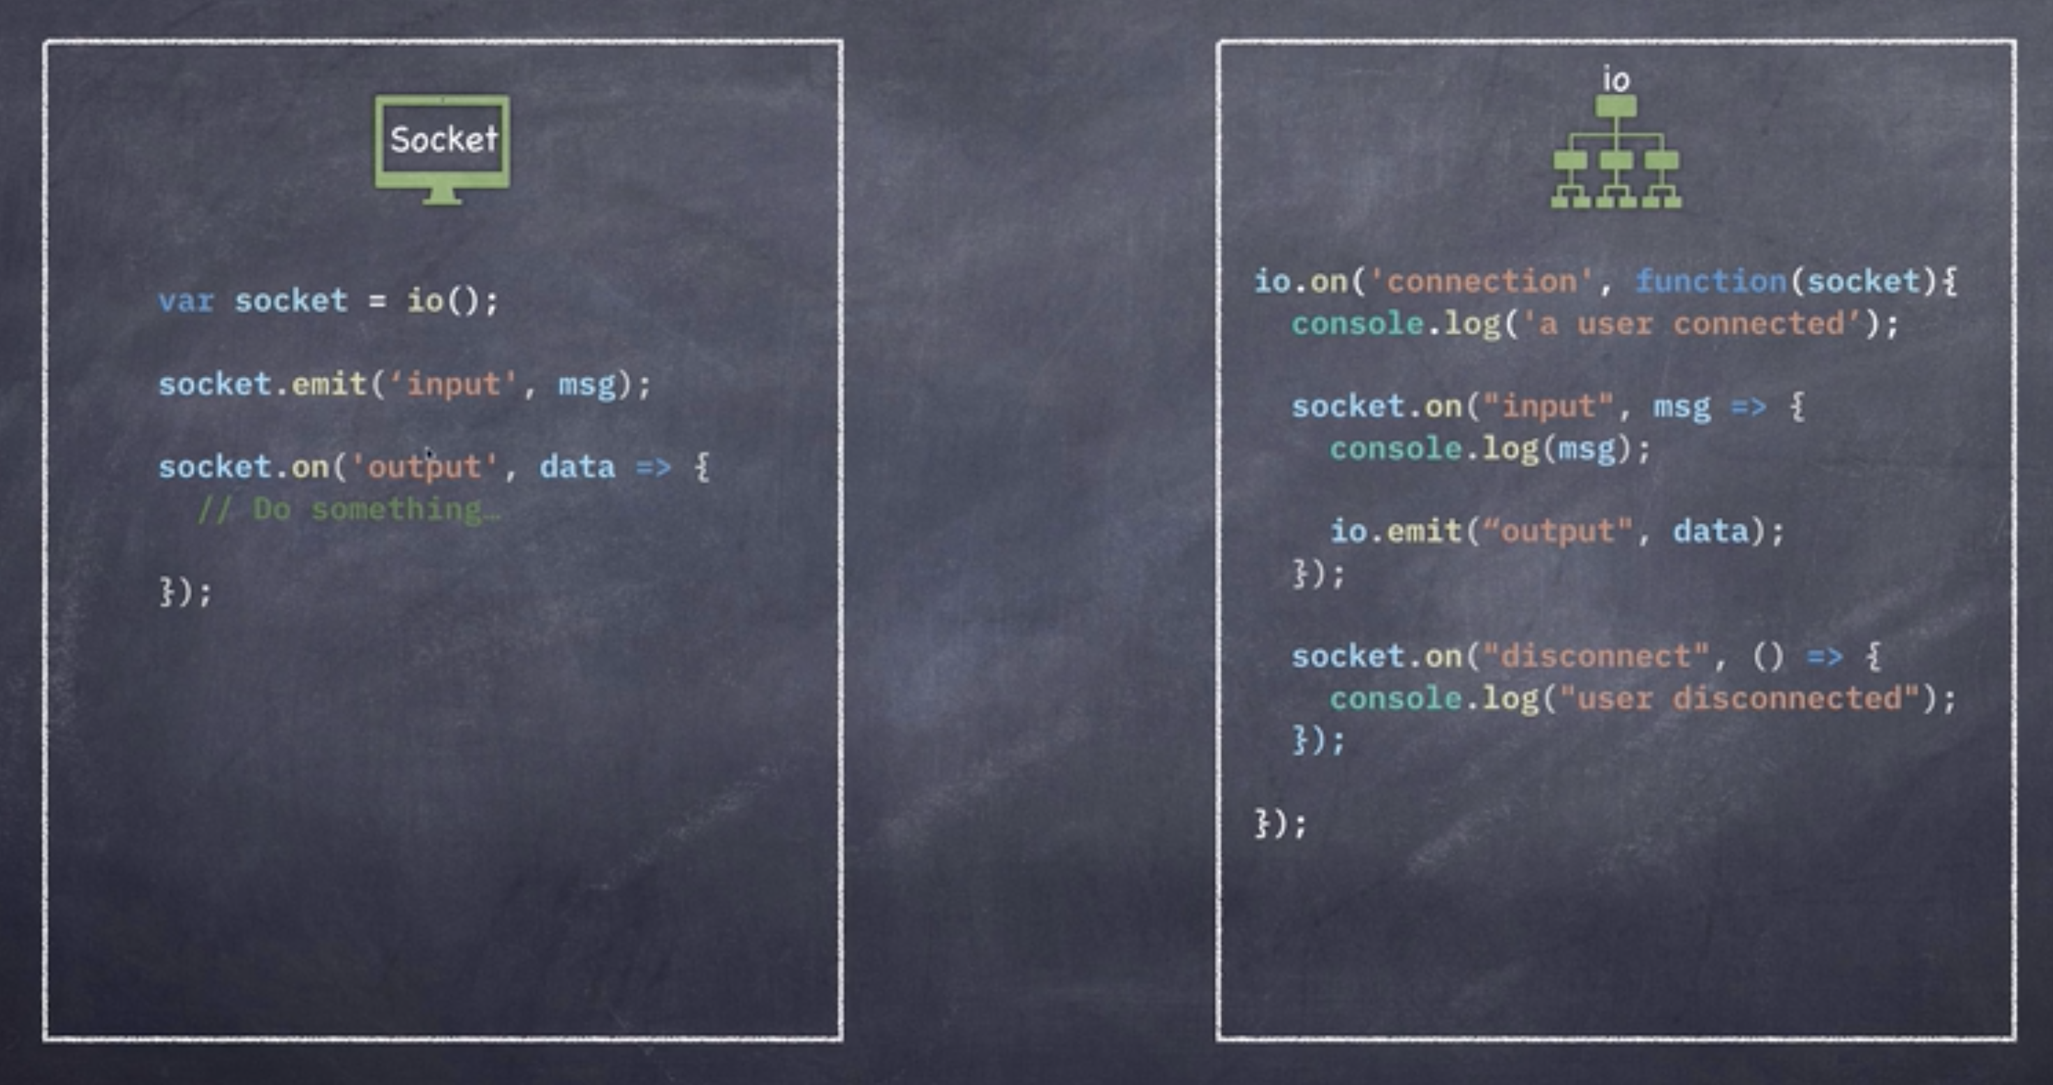

### Build your server

Step 1: Create the server: In your project, create a new file called server.js

**server.js**

|  |
| --- |
| const express = require("express");  const app = express();  const server = require("http").createServer(app);  app.get("/", (req, res) => {  res.sendFile(__dirname + "/index.html");  });  const port = process.env.PORT || 5000;  server.listen(port, () => console.log(`Server is running on port ${port}`)); |

Step 2: Add the socket.io and the connection logic: in the server.js add code

**server.js**

|  |
| --- |
| const express = require("express");  const { isObject } = require("util");  const app = express();  const server = require("http").createServer(app);  const io = require("socket.io")().listen(server).sockets;  app.get("/", (req, res) => {  require("socket.io") returns us the class. To use instance method (Eg, listen), we need to create an object with ()  Alternative:  const Server = require("socket.io");  const io = (new Server()).listen(server).sockets;  res.sendFile(__dirname + "/index.html");  });  io.on('connection', socket => {  console.log('one user connected');  })  const port = process.env.PORT || 5000;  server.listen(port, () => console.log(`Server is running on port ${port}`)); |

Step 3: Add the disconnection: in the server.js add code

**server.js**

|  |
| --- |
| const express = require("express");  const { isObject } = require("util");  const app = express();  const server = require("http").createServer(app);  const io = require("socket.io")().listen(server).sockets;  app.get("/", (req, res) => {  res.sendFile(__dirname + "/index.html");  });  io.on('connection', socket => {  console.log('one user connected');  socket.on('disconnect', () => {  console.log('one user disconnected');  })  })  const port = process.env.PORT || 5000;  server.listen(port, () => console.log(`Server is running on port ${port}`)); |

### Front end: socket.io connection

Step 4: Add Socket CDN in index.html file

At the bottom of your <body> part, add this:

<script src="https://cdn.socket.io/4.0.1/socket.io.js"></script>

Step 5: Add our logic code, under the Step 1 <script>, create another <script>

<script>

(function () {})();

</script>

Step 6: Add the connection code:

<script>

(function () {

// Connect to server with socket.io

let socket = io({ timeout: 5000, "connect timeout": 5000 });

// check for connection

if (socket !== undefined) {

console.log("Connected with server ...");

}

})();

</script>

Step 7: Verify the connection works

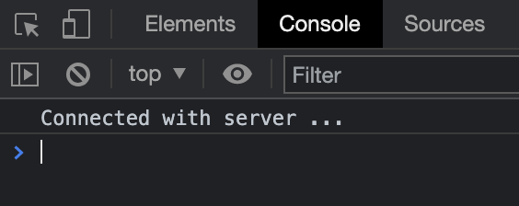

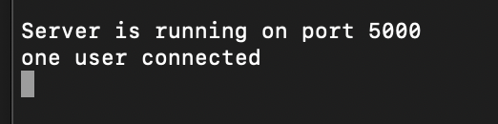

And when you refresh the page of localhost:5000

The server side console should show:

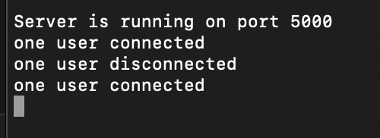

By step 7, your code should look like this:

**index.html**

|  |
| --- |
| <!DOCTYPE html>  <html>  <head>  <link  href="https://fonts.googleapis.com/icon?family=Material+Icons"  rel="stylesheet"  />  <!-- Compiled and minified CSS -->  <link  rel="stylesheet"  href="https://cdnjs.cloudflare.com/ajax/libs/materialize/1.0.0/css/materialize.min.css"  />  <meta name="viewpoint" content="width-device-width, initial-scale=1.0" />  <title>Let's Chat!</title>  </head>  <body>  <nav>  <div class="nav-wrapper blue-grey">  <a href="#" class="brand-logo center"> Let's Chat!</a>  </div>  </nav>  <div class="row">  <!-- message area -->  <div id="chat-div" class="col s8" style="display: none">  <div class="card blue-grey darken-1">  <div class="card-content white-text" id="messages"></div>  <div class="card-action white">  <!-- message from -->  <form id="message-form">  <div class="input-field">  <textarea  type="text"  id="textarea"  class="materialize-textarea"  ></textarea>  <label class="active" for="textarea">MESSAGE</label>  </div>  <div class="right-align">  <button  class="btn waves-effect waves-light btn-small"  type="submit"  name="action"  >  SEND  <i class="material-icons right">send</i>  </button>  </div>  </form>  </div>  </div>  </div>  <!-- login area -->  <div id="login-div" class="col s8" style="display: block">  <div class="card">  <div class="card-content">  <span class="card-title teal-text text-lighten-1"  >Give yourself a nickname</span  >  <!-- login form -->  <form id="login-form">  <div class="input-field">  <input type="text" id="name" />  <label class="active" for="name">Name</label>  </div>  <div class="right-align">  <button  class="btn waves-effect waves-light btn-small"  type="submit"  name="action"  >  Let's Chat! <i class="material-icons right">chat</i>  </button>  </div>  </form>  </div>  </div>  </div>  <!-- connected user list -->  <div class="col s4">  <h3 class="flow-text center teal-text text-lighten-1">  CONNECTED USER  </h3>  <ul class="collection" id="user-list"></ul>  </div>  </div>  <script src="https://cdn.socket.io/4.0.1/socket.io.js"></script>  <script>  (function () {  // Connect to server with socket.io  let socket = io({ timeout: 5000, "connect timeout": 5000 });  // check for connection  if (socket !== undefined) {  console.log("Connected with server ...");  }  })();  </script>  </body>  </html> |

### Front end: login part

Step 8: Fetch DOM elements, in index.html at the beginning of your function, add:

const loginForm = document.getElementById("login-form");

const messageForm = document.getElementById("message-form");

const messages = document.getElementById("messages");

const userList = document.getElementById("user-list");

const loginDiv = document.getElementById("login-div");

const chatDiv = document.getElementById("chat-div");

Step 9: Give Login Form a listener, in index.html at the end of the function (inside of it), add:

loginForm.addEventListener("submit", (e) => {

e.preventDefault();

});

Step 10: Add the logic to fetch the user input name and send it to the server

loginForm.addEventListener("submit", (e) => {

e.preventDefault();

const userName = document.getElementById("name").value;

// emit login

socket.emit("login", userName, () => {});

});

Step 11: Switch the two forms using CSS in the emit() method

// Submit login form

loginForm.addEventListener("submit", (e) => {

e.preventDefault();

const userName = document.getElementById("name").value;

// emit login

socket.emit("login", userName, () => {

loginDiv.style = "display:none";

chatDiv.style = "display: block";

});

});

Step 12: Add welcome message:

// Submit login form

loginForm.addEventListener("submit", (e) => {

e.preventDefault();

const userName = document.getElementById("name").value;

// emit login

socket.emit("login", userName, () => {

loginDiv.style = "display:none";

chatDiv.style = "display: block";

//add welcome message

let message = document.createElement("p");

message.setAttribute("class", "center blue-grey-text text-lighten-2");

message.textContent = `Welcome ${userName} joined Chat!`;

messages.appendChild(message);

messages.insertBefore(message, messages.lastElementChild);

});

By step 12 your <script> in index.html should look like this:

**index.html**

|  |
| --- |
| …  <script src="https://cdn.socket.io/4.0.1/socket.io.js"></script>  <script>  (function () {  // Get elements  const loginForm = document.getElementById("login-form");  const messageForm = document.getElementById("message-form");  const messages = document.getElementById("messages");  const userList = document.getElementById("user-list");  const loginDiv = document.getElementById("login-div");  const chatDiv = document.getElementById("chat-div");  // Connect to server with socket.io  let socket = io({ timeout: 5000, "connect timeout": 5000 });  // check for connection  if (socket !== undefined) {  console.log("Connected with server ...");  }  // Submit login form  loginForm.addEventListener("submit", (e) => {  e.preventDefault();  const userName = document.getElementById("name").value;  // emit login  socket.emit("login", userName, () => {  loginDiv.style = "display:none";  chatDiv.style = "display: block";  //add welcome message  let message = document.createElement("p");  message.setAttribute(  "class",  "center blue-grey-text text-lighten-2"  );  message.textContent = `Welcome ${userName} joined Chat!`;  messages.appendChild(message);  messages.insertBefore(message, messages.lastElementChild);  });  });  })();  </script>  </body>  </html> |

### Server side: handle login event

Now, we are back to our server.js file, we should have our io.on(“connection”, …) like this:

io.on("connection", (socket) => {

console.log("one user connected");

socket.on("disconnect", () => {

console.log("one user disconnected");

});

});

Step 13: Validate received user name, to make sure it’s not empty, on a login event

io.on("connection", (socket) => {

console.log("one user connected");

//login

socket.on("login", (name, callback) => {

if (name.trim().length === 0) {

return;

}

callback(true);

});

socket.on("disconnect", () => {

console.log("one user disconnected");

});

});

Step 14: Store valid user name and update the connected user list

let connectedUser =[];

io.on("connection", (socket) => {

console.log("one user connected");

let userName = "";

//login

socket.on("login", (name, callback) => {

if (name.trim().length === 0) {

return;

}

callback(true);

userName = name;

connectedUser.push(userName);

});

socket.on("disconnect", () => {

console.log("one user disconnected");

});

});

Step 15: Add logic to remove user when user got disconnected,

socket.on("disconnect", () => {

console.log("one user disconnected");

connectedUser.splice(connectedUser.indexOf(userName),1);

});

Step 16: Add logic for Server send out (emit) the updated user list. So we define a function to do that, and call that function in event callbacks of both “connection” and “disconnect”

let connectedUser = [];

io.on("connection", (socket) => {

console.log("one user connected");

updateUserName();

let userName = "";

//login

socket.on("login", (name, callback) => {

if (name.trim().length === 0) {

return;

}

callback(true);

userName = name;

connectedUser.push(userName);

updateUserName();

});

socket.on("disconnect", () => {

console.log("one user disconnected");

connectedUser.splice(connectedUser.indexOf(userName), 1);

updateUserName();

});

function updateUserName() {

io.emit("loadUser", connectedUser);   
 // We’ll define “loadUser” event in html later

}

});

Step 17: Verify the user list got updated as expected, add two console.log() and check on server

let connectedUser = [];

io.on("connection", (socket) => {

console.log("one user connected");

updateUserName();

let userName = "";

//login

socket.on("login", (name, callback) => {

if (name.trim().length === 0) {

return;

}

callback(true);

userName = name;

connectedUser.push(userName);

console.log(connectedUser);

updateUserName();

});

socket.on("disconnect", () => {

console.log("one user disconnected");

connectedUser.splice(connectedUser.indexOf(userName), 1);

console.log(connectedUser);

updateUserName();

});

function updateUserName() {

io.emit("loadUser", connectedUser);

}

});

Step 18: Open two pages of localhost:5000 in browser, send user name as “aaa” and “bbb” , and then close the second page. On server console we should see this:

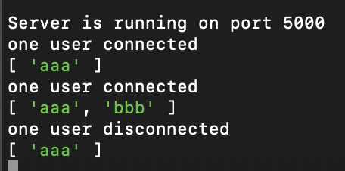

### Front end: handle **loadUser** event

Now, we get back to index.html file to add the event handler for loadUser event.

Add it in our function, after the connection checking:

// check for connection

if (socket !== undefined) {

console.log("Connected with server ...");

}

Step 19: Clear the existing user list

// check for connection

if (socket !== undefined) {

console.log("Connected with server ...");

}

// Update user list

socket.on("loadUser", (users) => {

userList.innerHTML = "";

});

// Submit login form

loginForm.addEventListener("submit", (e) => {

e.preventDefault();

const userName = document.getElementById("name").value;

Step 20: Show updated user list

// Update user list

socket.on("loadUser", (users) => {

userList.innerHTML = "";

users.forEach((user) => {

let userLi = document.createElement("li");

userLi.setAttribute("class", "collection-item");

userLi.innerHTML = `<h6 class="center">${user}</h6>`;

userList.insertBefore(userLi, userList.lastChild);

});

});

Step 21: Verify the behavior in browser (may need to restart your server)

After sending out user name, it should get shown in the connected user list.

(Also shown in the welcome message)

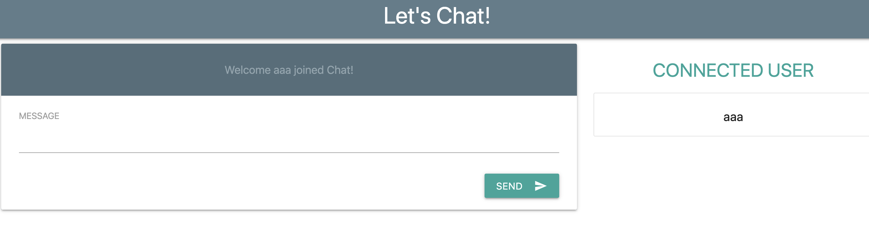

### Front end: Chat message

Now, we will move on to work on the message, in index.html.

Under loginForm.addEventListener( “submit”, e => {});

We will give a listener to our message Form, like this

Step 22: Add the listener:

// Submit Message

messageForm.addEventListener("submit", e => {});

Step 23: Add logic to fetch and send out the message content

// Submit Message

messageForm.addEventListener("submit", (e) => {

e.preventDefault();

const msg = document.querySelector("textarea").value;

document.querySelector("textarea").value = "";

socket.emit("chat message", msg);

});

Step 24: Add new message to the card when new message arrived

// Add message to card

socket.on("output", (data) => {});

Step 25: Add logic to the callback

// Add message to card

socket.on("output", (data) => {

let message = document.createElement("h6");

message.textContent = data.name + ": " + data.msg;

messages.appendChild(message);

messages.insertBefore(message, messages.lastChild);

});

### Server: Receive message and then send to all connected users

In server.js file add logic to handle new arrived message

Step 26: Add the event handler for chat message:

//receive chat message

socket.on("chat message", (msg) => {});

Step 27: Send out the new message along with the owner’s user name:

//receive chat message

socket.on("chat message", (msg) => {

//emit message data

io.emit("output", {

name: userName,

msg: msg,

});

});

### Deployment [Not for mark]: Get ready

Step 28: Make a new file named .gitignore, and write contents into it:

**.gitignore**

|  |
| --- |
| /node_modules  package-lock.json |

Step 29: Login your Heroku account, and then go to <https://dashboard.heroku.com/apps>

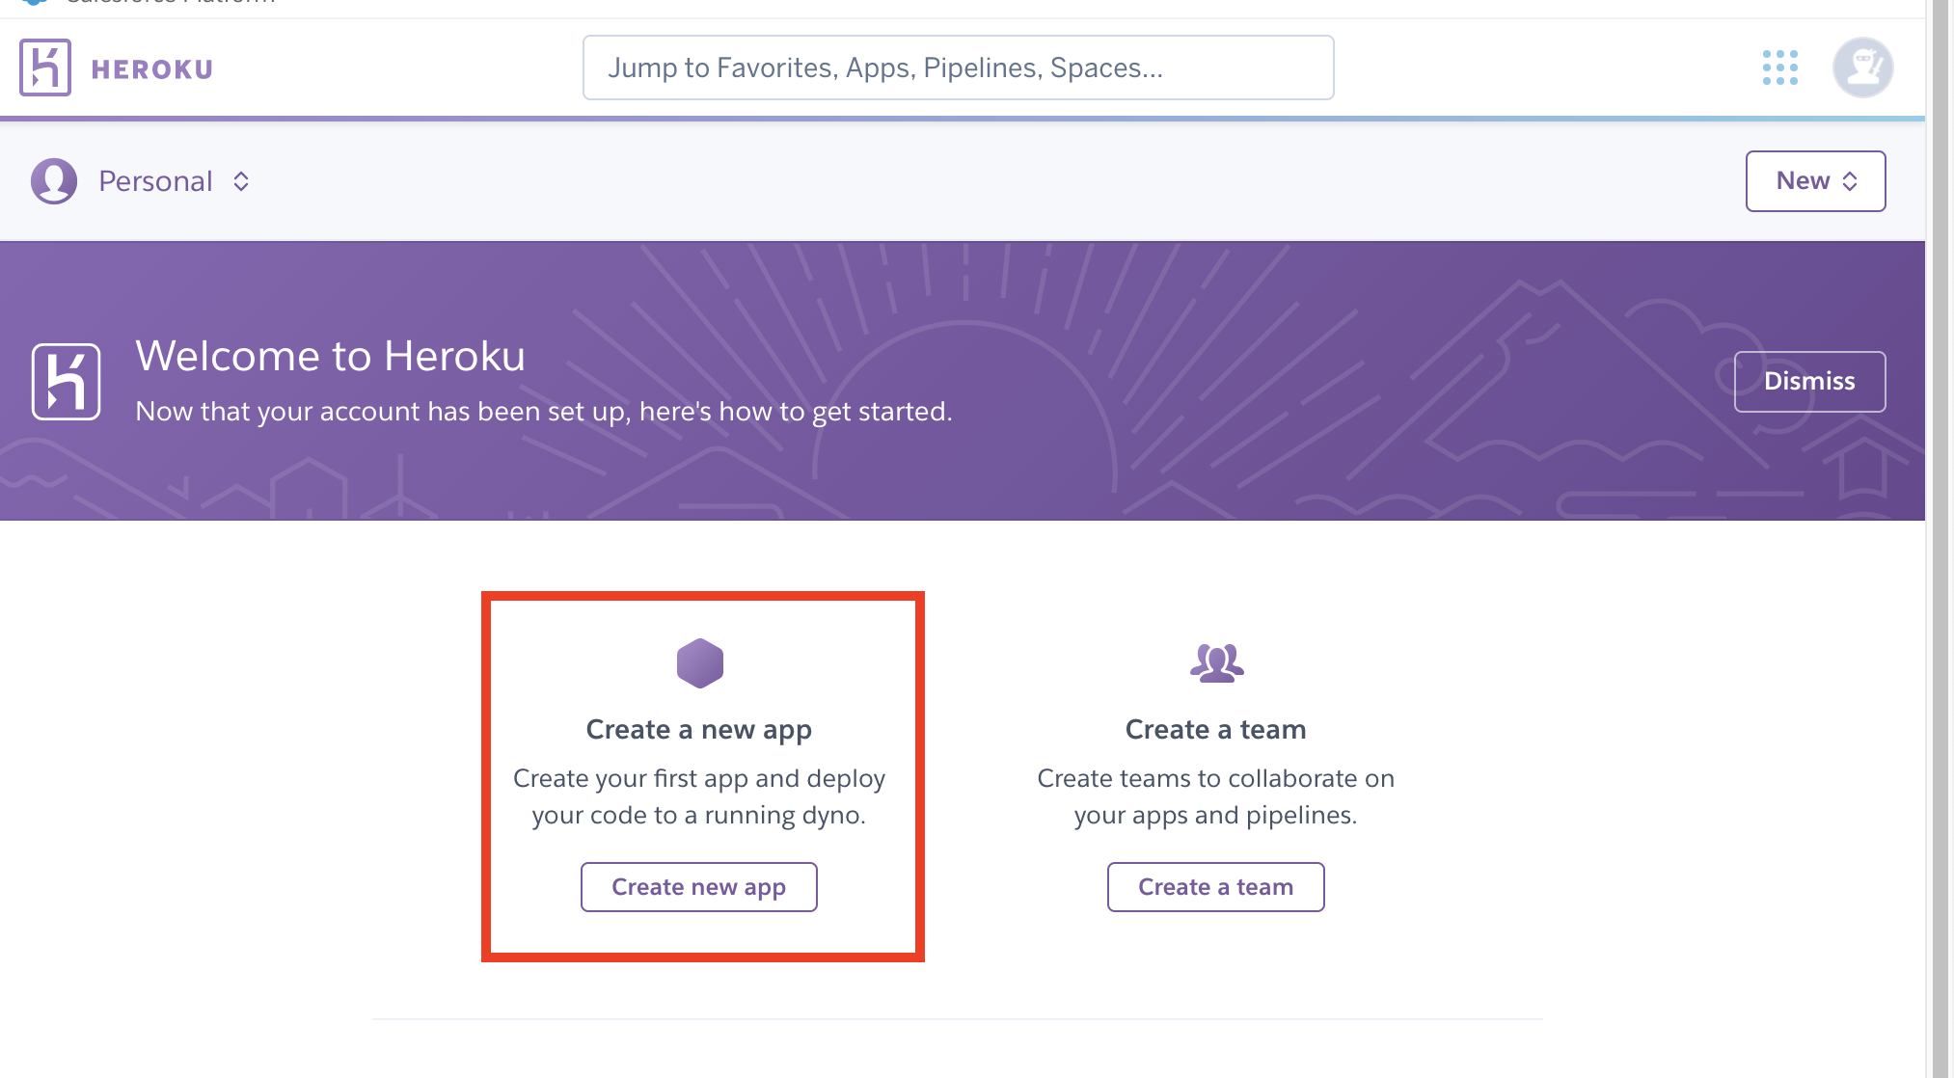

Step 30: Make a new project, and name it as comp-chat-a????????? (???????? is your student#)

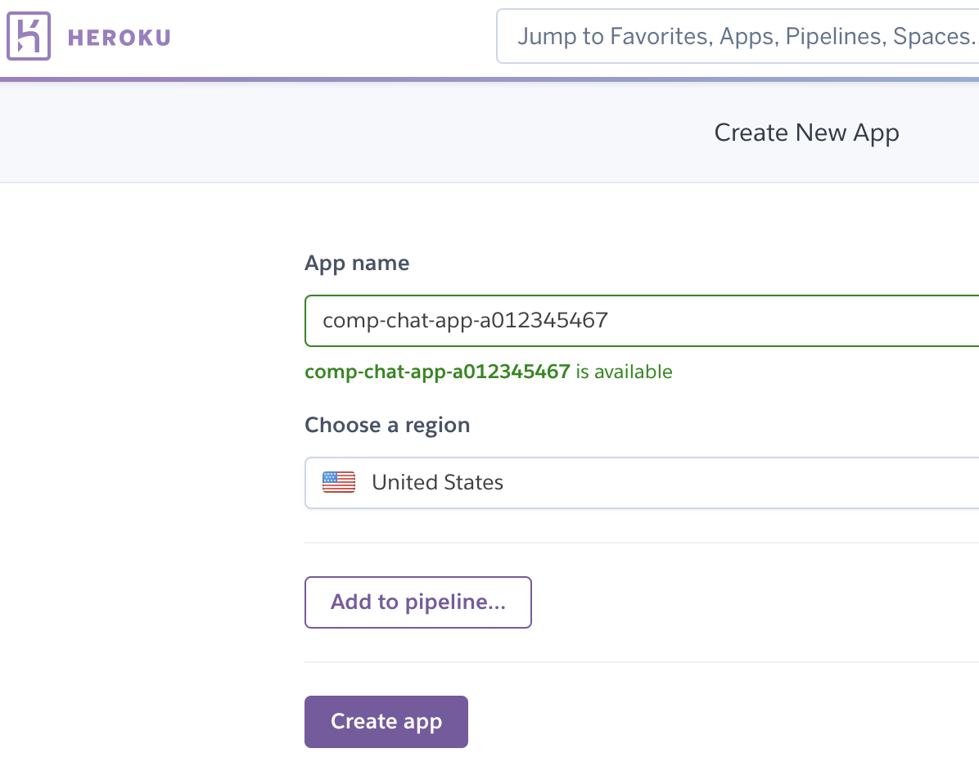

Step 31: [For Mac user] Install Heroku CLI, only if you haven’t do this

brew tap heroku/brew && brew install heroku

Step 32: Initialize the project in local

After login in Heroku in terminal, cd into your project folder, and then run:

git init

heroku git:remote -a comp-chat-app-a012345467

Step 33: Upload your project code

$ git add .

$ git commit -am "make it better"

$ git push heroku master

If everything went well, you should see this:

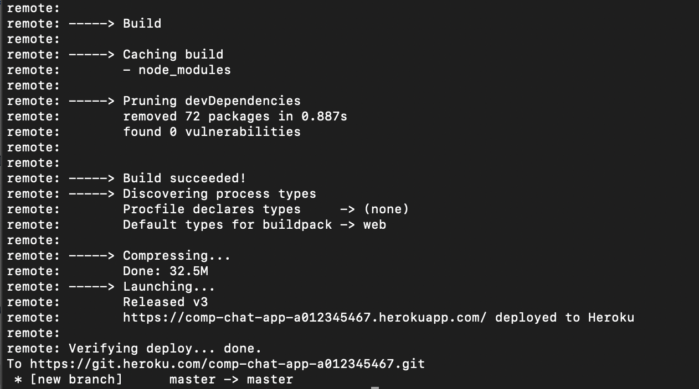

And that’s all, you should see your project from your URL

For my case, I have <https://comp-chat-app-a012345467.herokuapp.com/>